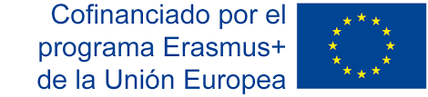
PROYECTO NUEVOS ULYSES: EN BUSCA DEL PATRIMONIO EUROPEO
PRESENTA: TERTULIA EN EL CAFÉ EUROPA
THEATRE PLAY SUMMARY
GATHERING AT EUROPE CAFÉ
By José Luis Algaba (Philosophy teacher at IES Federico G. Lorca in Albacete)
January 2019, 12 of our students who are in Year 11 (16-17 years old) have a starring role in this theatre play, which falls within the Project NEW ULYSSES: IN THE SEARCH OF A COMMON EUROPEAN HERITAGE, is part of the ERASMUS + programme of the European Union. This Project is carried out by three schools from France, Italy and Spain.
This theatre play is based on a dialogue among 11 Eropean thinkers who represent our philosophical tradition from the beginning of classical Greece to the present day: Aristotle, Saint Agustine, Machiavelli, Erasmus, Kant, Olympe de Gouges, Marx, Nietzsche, Ortega y Gasset, Hannah Arendt and Habermas, a discussion about Europe and Philosophy.

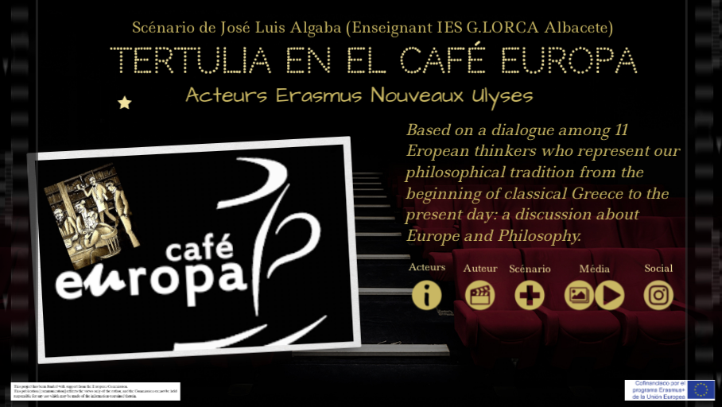
Aristotle is aware of the fact that self-sufficiency is not possible in any state, because we live in the era of globalization. Saint Augustine believes that the Christian values have contributed to the creation of Europe, as well as Erasmus, whose theories have been criticised by the enlightened, the new enlightened and the masters of suspicion, such as Kant, Olympe de Gouges, Marx, Nietzsche and Habermas, who will raise the need to create the rule of law based on reason, the need to extend the rights of citizenship to women, a criticism of the liberal-capitalist state, which neglects the workers´ rights, a criticism of the decadent Christian values and the need to reach an agreement by means of dialogue. Machiavelli will also stand out from the ethic and religious values to bet on a strong State which will bring stability to the Government.
Finally, Ortega and Hannah Arendt will raise the issues about mass society features and the origin of totalitarism, as well as the need of constructing the United States of Europe and a claim of non-work human activities which can contribute to humanise and free people.
To finish the play, Marx will perform on the piano “Mack the Knife”, which will be choreographed by a group of dancers.
ALGUNOS FRAGMENTOS ES ESPAÑOL E ITALIANO
Muy buenos días a todos, señoras y señores filósofos. Les damos la bienvenida a la tertulia de los jueves en este “Café Europa”. Hoy, que tenemos una audiencia especial, francesa, italiana y española, el tema que vamos a tratar va a ser precisamente Europa y la filosofía. Ya sé que algunos de ustedes han tenido que viajar desde muy lejos para poder estar hoy aquí, de modo que les agradecemos mucho su presencia. Pidan a nuestras camareras lo que les apetezca, y pónganse cómodos. Señor Aristóteles, le concedo a usted la palabra por ser el primero en orden cronológico.
Buongiorno a tutti, signore e signori filosofi. Benvenuti alla chiacchierata del giovedì al "Café Europa" Oggi che abbiamo un pubblico speciale, francese, italiano e spagnolo, il tema di cui discuteremo è proprio l'Europa e la filosofia. So che alcuni di voi hanno dovuto affrontare un lungo viaggio per essere qui oggi, quindi vi ringraziamo molto per la vostra presenza. Chiedete alle nostre cameriere quello che desiderate e accomodatevi. Signor Aristotele, Le do la parola per essere il primo in ordine cronologico.
Pues bien, señoras y señores filósofos, señoras y señores del público, me van a disculpar que ponga fin a esta interesantísima discusión sobre Europa, pero nuestro Carlos Marx, que además es un excelente pianista, y nuestros estupendos bailarines, están deseosos de ofrecer esta pequeña coreografía a todo nuestro público internacional que hoy nos visita. ¡Va por vosotros, amigos italianos y amigos franceses!
Bene, signore e signori filosofi, signore e signori del pubblico, mi scuso per aver messo fine a questa interessante discussione sull'Europa, ma il nostro Karl Marx, che è anche un eccellente pianista, e i nostri meravigliosi ballerini, sono desiderosi di offrire questa piccola coreografia a tutto il nostro pubblico internazionale che è venuto a visitarci oggi.
E’ per voi amici italiani e amici francesi!

